(Approx. 1,324 words)

Memory Cards
By Dick Maybach, Member, Brookdale Computer Users’ Group, NJ
December 2014 issue, BUG Bytes
www.bcug.com
n2nd (at) att.net

USB memory sticks and Secure Data (SD) cards are the most convenient media for transferring data among computers. Both are compact, inexpensive, and rugged and have capacities of up to several Gbytes. Above this, you have little choice but to use a considerably larger, more fragile, and more expensive external hard disk. CDs and DVDs are less expensive, but are larger, more fragile, and have lower capacities; moreover, fewer modern portable PCs have optical media drives than in the past. Finally, writable optical media have reliability issues, especially if they are subjected to high temperatures or humidifies. It's also true that memory sticks and cards experience fatigue in that they will fail after a finite number of write operations. However, the limit is so large that you can ignore them for devices used for the applications we're discussing here, although it is a consideration for internal solid state disks.

For many years, I've carried in my keycase a USB memory stick with two partitions, one with a bootable diagnostic operating system and the other with a FAT32 file system that is available to Linux, OS X, and Windows. Thus, I always have with me a computer toolkit and a means of transferring files. (If you do the same, make the first partition the FAT32 one. While a PC can boot from any partition, once Windows is running it can read only the first partition on a memory stick. Other operating system don't have this limitation.)

We have seen three generations of Universal Serial Bus (USB) devices. USB 1 has a top speed of 12 Mbits/s, which because of protocol overhead results in a practical data transfer rate of about 1 Mbyte/s. Such devices are now obsolete. USB 2 claims a speed of 480 Mbits/s, and protocol overhead reduces this to no more than 35 Mbytes/s, but only the fastest memory sticks can approach this. Finally, USB 3 has a maximum transfer rate of 5 Gbit/s, which could allow transfer rates of over 600 Mbyte/s, but this is faster than what current memory chips and readers can achieve. Actual test results show that, depending on the reader, USB 3 memory sticks are at most twice as fast as USB2 devices, and in some cases the difference is negligible. The good news about USB is that there are few compatibility issues; you will experience reliable data transfers with almost any combination of memory stick and reader.

The Secure Digital Card (SDC) situation is more complex, as it includes four families and three physical sizes. The families are SD (standard capacity), SDHC (high capacity), SDXC (extended capacity), and SDIO (which combines storage and input/output functions, such Bluetooth). There is also an SDXC family that is designed for use in video cameras and uses the proprietary Microsoft exFAT file format. The three sizes are standard (32 x 24 mm), mini (21.5 x 20.0 mm), and micro (11.00 x 15.00 mm). Adapters are available that allow the use of mini and micro cards in standard slots. Early SD cards had an “x” rating, where x was equivalent to 1.2 Mbit/s; for example an 8x rating implied a read speed of 8 x 1.2 = 9.6 Mbit/s (about 1.2 Mbyte/s), with write speeds being substantially slower. Modern SD cards have a class rating that implies a minimum read and write speeds.
- Class 2 – 2 Mbyte/s
- Class 4 – 4 Mbyte/s
- Class 6 – 6 Mbyte/s
- Class 10 – 10 Mbyte/s
- UHS Class 1 (U1) – 10 Mbyte/s
- UHS Class 3 (U3) – 30 Mbyte/s
UHS cards are intended for HD video recording and require slots designed for them.

Because of their wide ranges of performance, there are significant compatibility issues with SD cards, and this is made worse by the shoddy quality of many low-cost readers, including some incorporated into laptops. Before purchasing an SD card, check the requirements of the device that will use it. New cards may have greater capacities than older devices can address. Version 2 of the SD spec changed the interface, with the result that new cards may not work in old devices, and old cards may not work in new devices. Finally, you should avoid SDX and UHS cards unless you are using hardware and software that specifically requires them.

I prefer USB memory sticks to SD cards for transferring data among PCs.
- On USB sticks the connector pins are protected, while on SD cards they are external where they can become dirty and can allow static electricity to damage the card.
- Most USB sticks have a mounting point that allows them to be carried in a key case or on a key ring; SD cards do not.
- Every modern computer has USB connectors, but most desktops lack one for SDCs. I have seen claims that after-market SD readers for desktops and those included on many laptops are not reliable, and some have damaged cards.
- The small size and black color of SD cards makes them easy to lose.
- USB sticks are thicker and appear to be more rugged than thin, plastic SD cards.
- There are fewer compatibility issues with USB memory sticks than with SD cards.

However, SD cards are the standard removable storage element for cell phones and digital cameras.

All the above assumes that you buy name-brand devices from established and reputable dealers. There is a lot of counterfeit merchandise floating around, USB 1 devices with USB 3 labels, low-speed SDCs with high-speed labels, and low capacity ones with high-capacity labels. Some of the latter, will lie about their capacities to your file manager; a claimed capacity of 16 Gbytes doesn't mean it can actually store that amount. If you find a really low price, it may be a bargain, but the only thing you know for sure is that it's cheap.

You can use the Windows program H2testw, available at http://www.heise.de/download/h2testw.html, to test any SD memory card or USB storage device to find its capacity and data transfer rate. (The Web site is in German, but you can run the program in English.) Just download the zip archive, unpack the program and its German and English readme files into the directory it creates. (The program is self-contained and runs from its directory; you don't install it.) Click the “English” button to obtain the first screen; then click the “Select target” button and choose the device to test. (I used an old, tiny USB stick for this demo, because although slow, its 120-Mbyte capacity means it's quick to test.) The process will destroy any data the device holds, so save anything important first. Start the test by clicking the “Write + Verify” button.
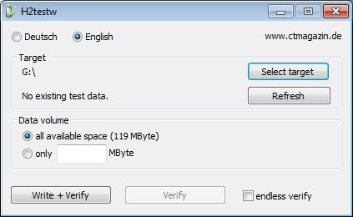

You may see the warning shown below, which appeared in this case on a device that was formatted to FAT32. If this is the only such message the test produces, you can ignore it.
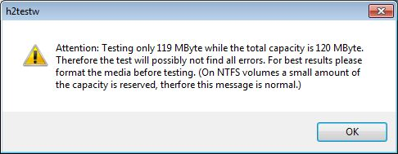

The following screen shows the test in process.
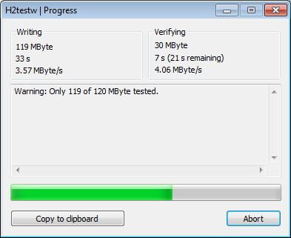

Here are the complete results, showing the actual device capacity and its read and write rates. Note that you have the option of copying them to the clipboard.
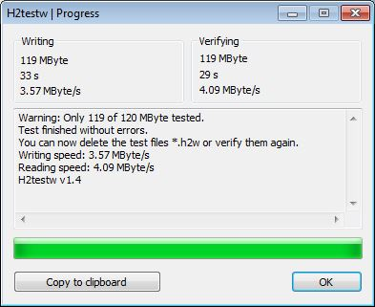

After you click OK, you'll see the following screen. Note that the “Write + Verify” button is grayed out. The device is now full of test files and you can run only the read test. As message in the previous screen says, you will have to delete these to rerun the write test.
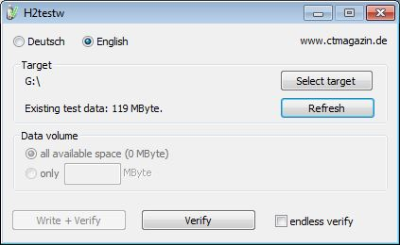

With this software you can verify the capacity and ensure that it works well. The speed measured however depends on both the stick or card and the host device. The tiny capacity of the device in this example resulted in a test time of about a minute; expect much longer times for modern multi-Gbyte devices. Nevertheless, it's worth taking the time to check a new SD card before trying to use it in your camera on a trip to Europe.

Dick Maybach

